Fundraising Templates
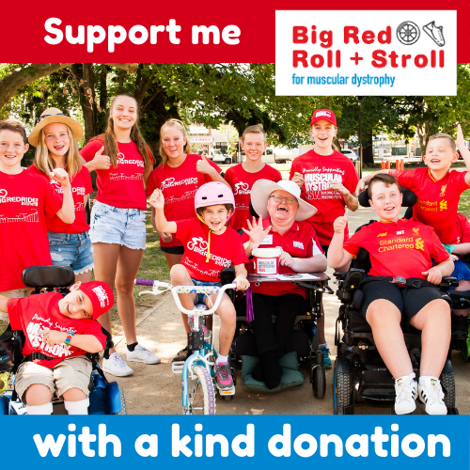
Your social media template
<copy/paste the following> Did you know there are almost 40,000 Australians living with a neuromuscular condition, 13,000 of whom live right here in NSW? I'm taking part in the Big Red Roll + Stroll for MD this March to raise vital funds and awareness. Will you support me? If you're able, please make a donation here: [Fundraiserurl,fallback=insert your fundraising page URL here] #RollandStroll4MD #BRRS2022
<Use this image with your post or use your own! You can download the image HERE. >
Your email template
<copy/paste the following>
Subject: Will you support me?
Hi friend,
I’m taking part in the Big Red Roll + Stroll to raise funds and awareness for people living with the devastating impacts of neuromuscular conditions.
Neuromuscular conditions affect almost 40,000 Australians, 13,000 of whom live right here in NSW, causing progressive deterioration of muscle strength and function. It’s a lifelong disease with no cure - which is why I’m raising vital funds that help make support and services possible.
Will you help me make a REAL difference? If you're able, please support me by making a tax-deductible donation here: <insert your donation page URL>
Together we can help people with a neuromuscular condition live the life they choose.
Thank you for your help!
Your friend

